Who invented predicate logic?
- In 1879, the German philosopher Gottlob Frege published the first satisfactory system of predicate logic.

Why is First Order logic called First Order?
- FOL is called “predicate logic”, since its atomic formulae consist of applications of predicate/relation symbols to terms.
- Why is it also called “first order”? Because its variables range only over individual elements from the interpretation domain.
- Maintains linear relationship (a polynomial of degree at most one).

Is there third order logic?
- Just as in first-order logic we have quantifiers that range over objects, second-order logic has quantifiers ranging over sets of objects, third-order logic has quantifiers ranging over sets of sets of objects, and so on.

Predicate Logic / First-Order Logic (FOL) / First-Order Logic (FOPL) / First-Order Predicate Calculus:

- A formal system of logic that extends propositional logic by introducing quantifiers (∀ for "for all" and ∃ for "there exists") and predicates to express properties of objects and relationships between them.
- Key components include predicates (attributes or properties)/relations, variables (representing subjects or objects), and quantifiers (like "for all" or "there exists") to specify the scope of variables.

Key Components of First-Order Logic
Predicates: These are symbols that represent properties of individuals or relationships between them. For example, IsMortal(x) could represent the property "x is mortal."
Predicate symbols (mapping from individuals to truth values): Teacher(Jerry, you), Bigger(sqrt(2), x)

Function: Function symbols (mapping individuals to individuals): Sqrt(9), Distance(Madison, Chicago)
Functions map elements to distinct values. They take arguments in the form of input elements and return a single value as output. For example: Age(Alice) = 25 → means "Alice's age is 25."

Variables: These represent unknown or unspecified individuals, such as x, y, or z. (symbols).

Constants: Symbols that represent specific, named individuals or objects, such as "Tom", Jerry, 2, Madison, Green, …

Domain of discourse: Variables range over individuals.

Quantifiers:
- Universal Quantifier (∀):
Means "for all" or "every". For example, ∀x (IsMortal(x)) means "All individuals x are mortal".
- Existential Quantifier (∃):
Means "there exists" or "some". For example, ∃x (IsMan(x)) means "There exists at least one x who is a man"

Logical Connectives:
Like in propositional logic, FOL uses connectives such as AND (∧), OR (∨), NOT (¬), IMPLIES (→), and IF AND ONLY IF (↔) to build complex formulas.

Knowledge Representation in FOPL
- In predicate logic the basic unit is a predicate-argument structure called an atomic sentence:
  - LIKES (azad, chocolate)
  - TALL (habib)
- Arguments can be any of:
  - constant symbol, such as ‘azad’
  - variable symbol, such as x
  - function expression, e.g., FATHER_OF (hasan)
- So we can have:
  - LIKES (X, chocolate)
  - FRIENDS (FATHER_OF (rita), FATHER_OF (choiti))
- These atomic sentences can be combined using logic connectives
  - LIKES (rita, hasan) ˄ TALL (hasan)
  - BASKET_BALL_PLAYER (hasan) → TALL (hasan)
- Sentences can also be formed using quantifiers
  - Ɐx LOVELY (x) Everything is lovely.
  - ᴲx LOVELY (x) Something is lovely.
  - Ɐx IN (x, garden) → LOVELY (x) Everything in the garden is lovely.

- All employees earning TK. 30,000 or more per year pay taxes.
∀x ((E(x) & GE (i (x), 30000)) → T(x)
- Some employees are sick today
ᴲy ((E(y) → S(y))
- No employee earns more than the president
∀x ∀y ((E(x) & P(y)) → ~GE((i (x), i (y)))

- Can have several quantifiers, e.g.,
  - ∀x ᴲy LOVES (x, y)
  - ∀x HANDSOME (x) → ᴲy LOVES (y, x)
- So we can represent things like:
  - All men are mortal.
∀x (Man(x) → Mortal(x))
  - No one likes hartal.
  - Everyone taking AI will pass their exams.
  - Every race has a winner.
  - Sajjad likes everyone who is tall.
  - Rita doesn’t like anyone who prefers arguments.
  - There is something small and slimy on the table.

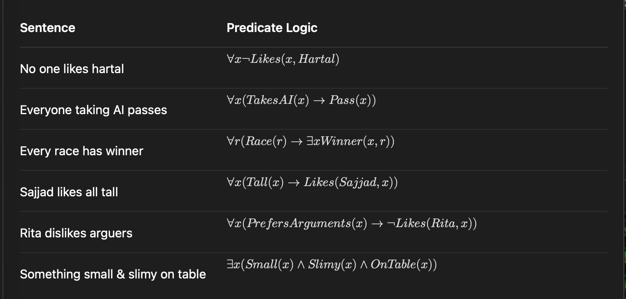

Logical Reasoning with FOL / Translating statements into logic:
Example-1:
Consider the following statements:
∀x (Cat(x) -> Mammal(x)) (All cats are mammals)
∀x (Mammal(x) -> Animal(x)) (All mammals are animals)
Cat(Tom) (Tom is a cat)

From these, we can logically infer:
Mammal(Tom) (Tom is a mammal)
Animal(Tom) (Tom is an animal)

Example-2:
"Every man is mortal": (∀x) (MAN(x) → MORTAL(x)).
"John is a man": MAN(john).
Therefore, “John is mortal": MORTAL(john). This is the conclusion derived from the premises.

Example-3:
- (∀x) ((MAN(x) → MORTAL(x)) ∧ MAN(john)) → MORTAL(john)
- This formula states: "If every man is mortal and John is a man, then John is mortal."

Semantics of Predicate Logic:
- There is a precise meaning to expressions in predicate logic.
- Like in propositional logic, it is all about determining whether something is true or false.
- ∀x P(x) means that P(x) must be true for every object x in the domain of interest.
- ᴲx P(x) means that P(x) must be true for at least one object x in the domain of interest.
- So if we have a domain of interest consisting of just two people, Hasan and Belal, and we know that TALL(hasan) and TALL(belal) are true, we can say that ∀x TALL(x) is true.

Representing Facts in First-Order Logic:
- Lucy is a professor
- All professors are people.
- John is the dean.
- Deans are professors.
- All professors consider the dean a friend or don’t know him.
- Everyone is a friend of someone.
- People only criticize people that are not their friends.
- Lucy criticized John .

Knowledge Base (First-Order Logic):
- is-professor(lucy)
- ∀x (is-professor(x) → is-person(x) )
- is-dean(John)
- ∀x (is-dean(x) → is-prof(x))
- ∀x (∀y ( is-prof(x) ∧ is-dean(y) → is-friend-of(y,x) ˅ ̚ knows(x, y) ) )
- ∀x (ᴲy (is-friend-of (y, x) ) )
- ∀x (∀y (is-person(x) ∧ is-person(y) ∧ criticize (x,y) → ̚ is-friend-of (y,x)))
- criticize(lucy, John )

Question: Is John no friend of Lucy? ̚ is-friend-of(John, lucy)

Some Examples:
- Jack owns a dog.
- Every dog owner is an animal lover.
- No animal lover kills an animal.
- Either Jack or Curiosity killed the cat, who is named Tuna.

Did Curiosity kill the cat?

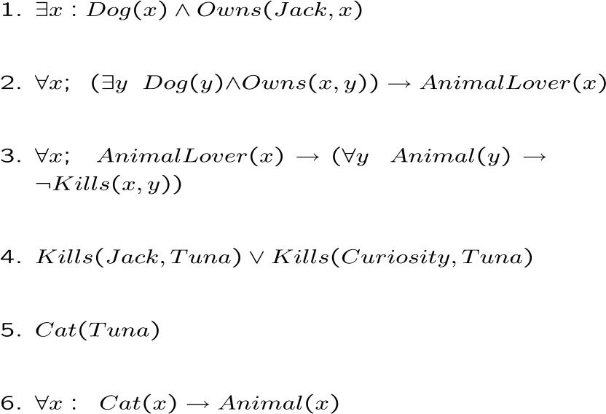

- All humans are mammals.
∀x (human(x) → mammal(x) )
Means if x is a human, then x is a mammal

- Some humans are male.
ᴲx (human(x) ∧ male(x) )
Means there is an x who is a human and is a male

- Everyone likes everyone.
∀x ∀y likes(x, y)

- Everyone likes someone.
∀x ᴲy likes(x, y)

- Everybody sleeps.
∀x sleep(x)

- Somebody does not sleep.
ᴲx ̚ sleep(x)

- Everyone doesn’t see something.
∀x ᴲy ̚ sees(x, y)

- John loves everyone.
∀x LOVE(john, x)

- Every father loves his child.
∀x LOVE(father(x), x).

- Good people always have friends.
∀x (person(x) ˄ good(x) → ᴲy(friend(x, y)) )

- Busy people sometimes have friends.
ᴲx (person(x) ˄ busy(x) ˄ ᴲy(friend(x, y)) )

- Bad people never have friends.
∀x (person(x) ˄ bad(x) → ̚ ᴲy(friend(x,y)))

- "Every customer who makes a purchase receives an invoice".
∀x(Customer(x) ˄ Purchases(x, Product) → ReceivesInvoice(x))

- All students taking AI are genius.
∀x: student(x) ˄ takingAI(x) → genius(x)

- Some students taking AI are genius and hardworking.
ᴲx: student(x) ˄ takingAI(x) → genius(x) ˄ hardworking(x)

- "All apples are red."
∀x (Apple(x) → Red(x))

- "Mamun has a cute dog."
∃x (Owns(Mamun, x) ∧ Dog(x) ∧ Cute(x))

Example:
Translate the text "Every man is mortal. John is a man. Therefore, John is mortal" into a FOPL formula.

Solution:
Every man is mortal: ∀x (MAN(x) → MORTAL(x))
John is a man: MAN(John)
John is mortal: MORTAL(John)

The whole text can be represented by the following formula:
∀x ((MAN(x) → MORTAL(x)) ˄ MAN(John)) → MORTAL(John)

Q-1:Translate the following English sentences into Predicate Logic
- Everyone is loyal to someone.
- All Romans were either loyal to Caesar or hated him.
- For every number, there is one and only one immediate successor.
- There is no number for which 0 is immediate successor.
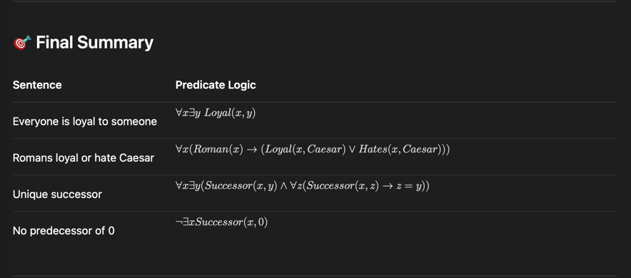

Q-2: Evaluate truth values of the following: (define your own interpretations).
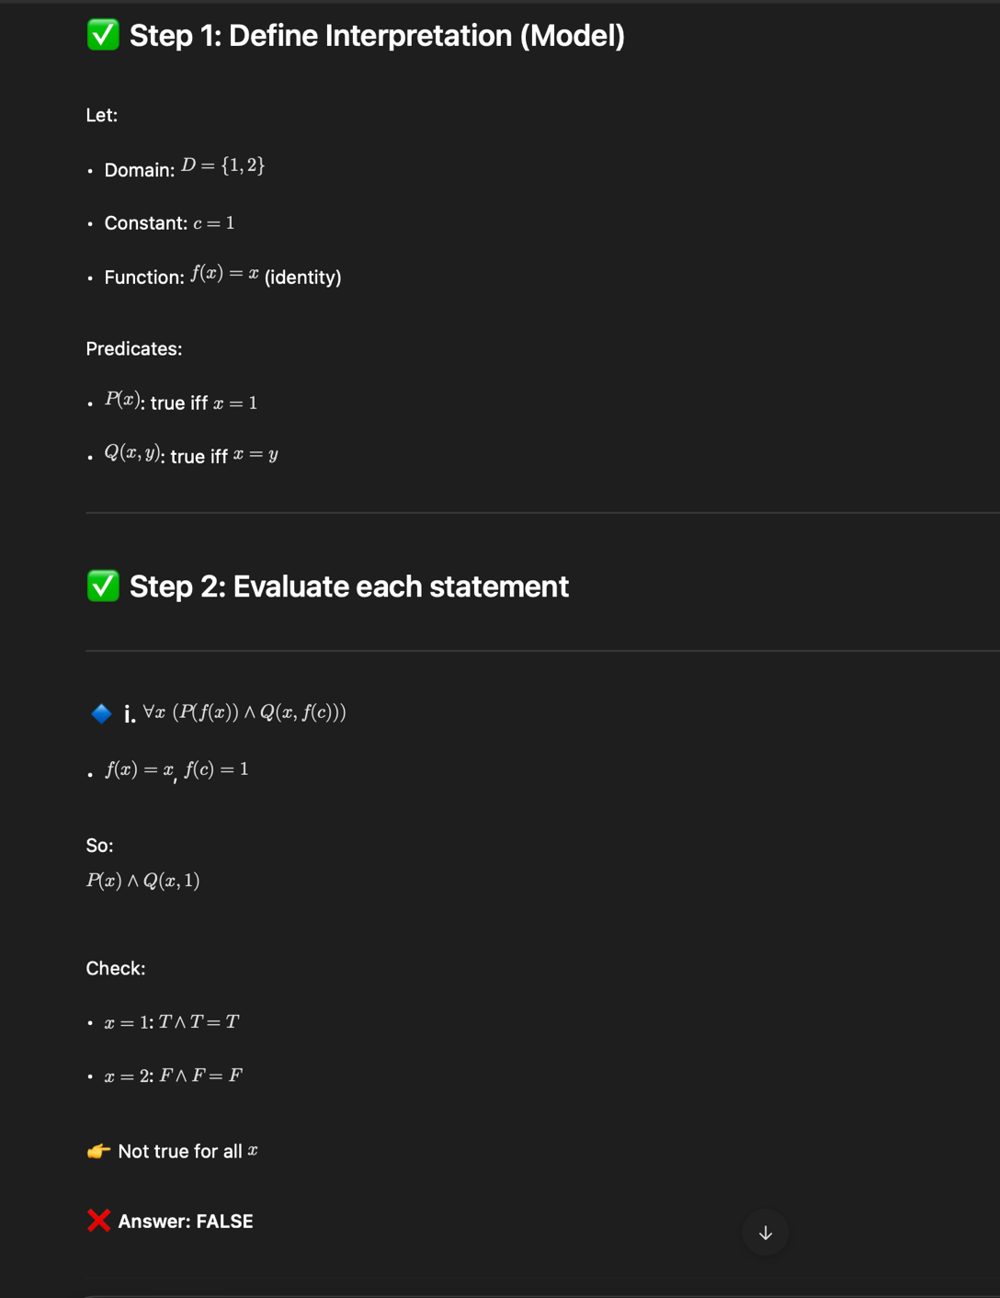
- (ᴲx) ( P(f (x) ) ˄ Q(x, f (c) ) )
- (ᴲx) ( P(x) ˄ Q(x, c) )
- (ᴲx) ( P(x) → Q(x, c) )
- (∀x) (ᴲy) ( P(x) ˄ Q(x, y) )
- (∀x) (ᴲy) ( P(x) → Q( f (c), y) )

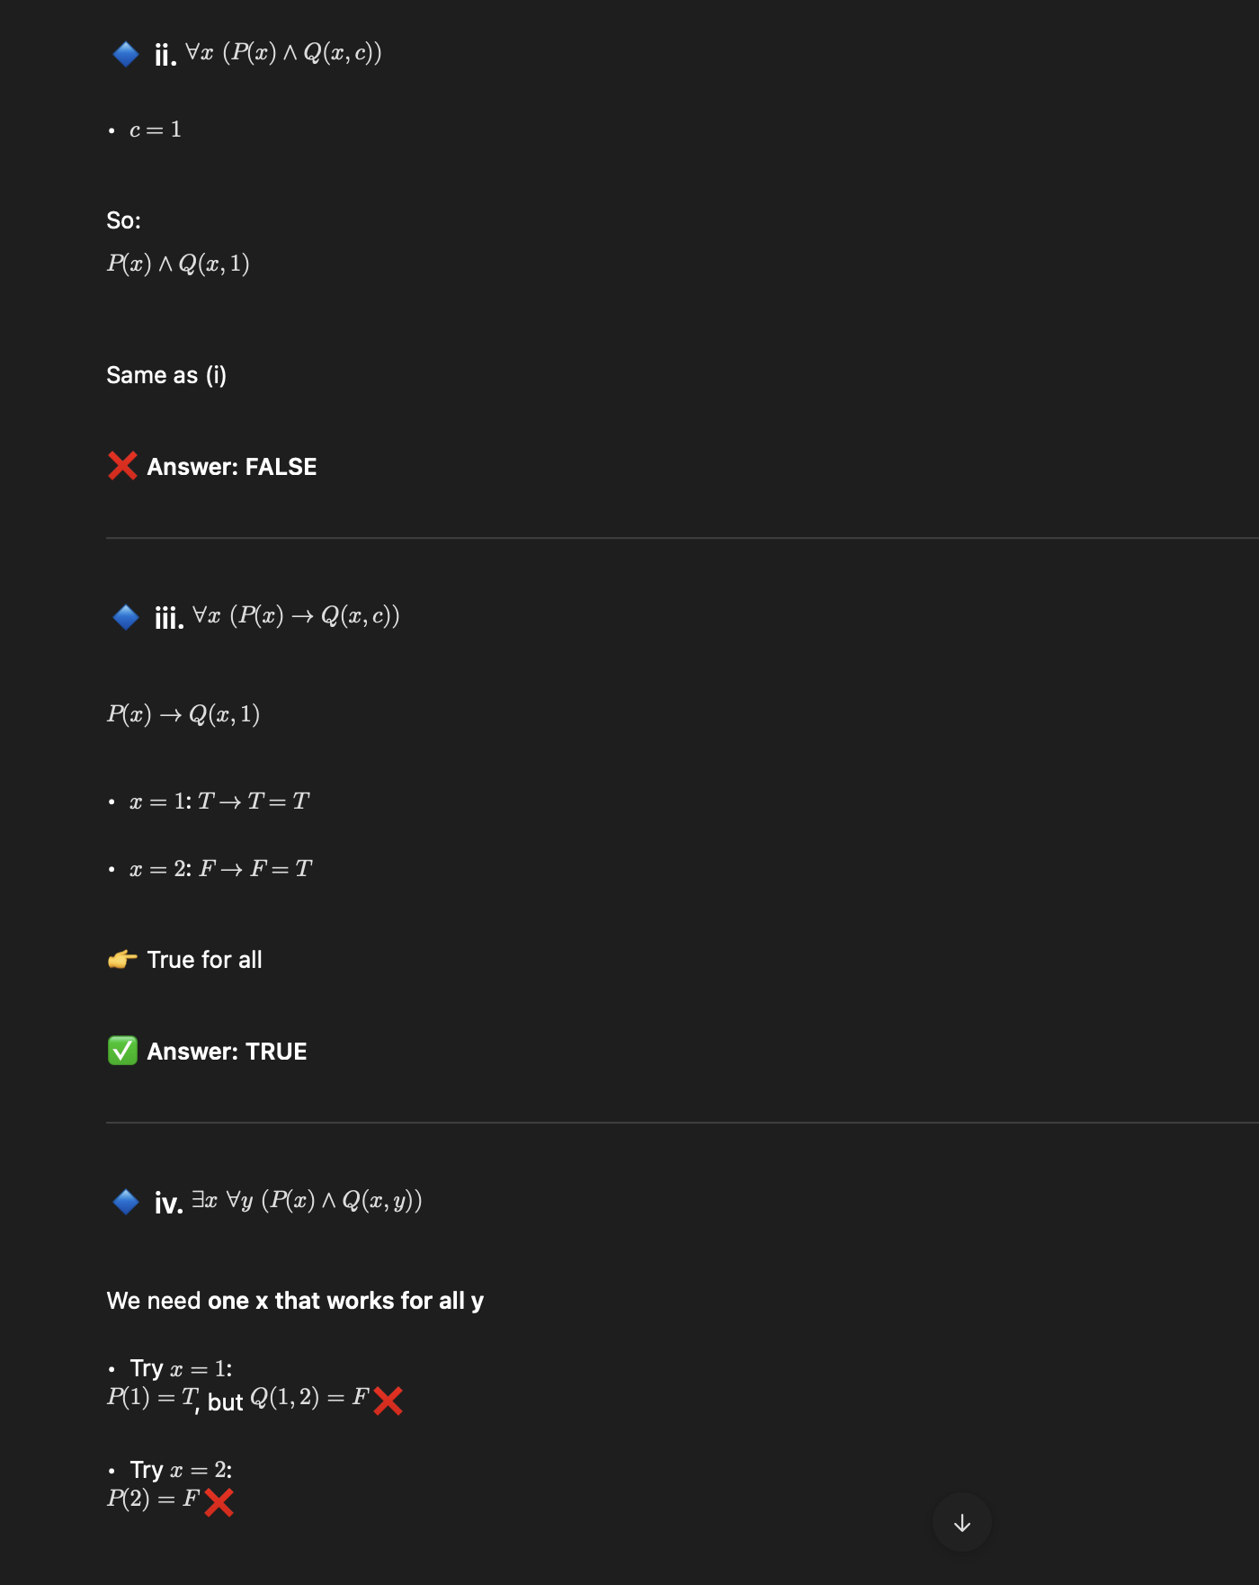

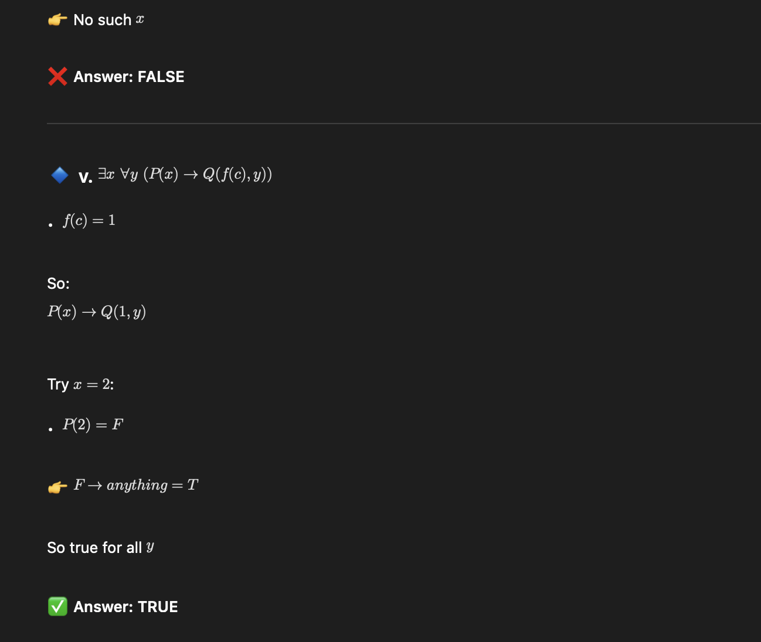

Challenges and Limitations of First Order Predicate Logic:
When utilizing First-Order Logic (FOPL) for knowledge representation and reasoning, several key challenges and limitations arise, as follows −

- Challenges in Handling Uncertainty: FOL requires facts to be definitively true or false, making it difficult to represent probabilistic or uncertain information.
- High Computational Demands: When dealing with extensive knowledge bases, logical inference in FOL can become slow and resource-intensive.
- Limited Expressive Power: Concepts from the real world that involve fuzzy or probabilistic logic, such as "most people" or "approximately," are difficult for FOL to articulate.
- Rigid Rule-Based Framework: The necessity for facts and rules to be explicitly defined results in a structure that is inflexible and struggles to incorporate new information.
- Common-Sense Thinking Difficulty: FOL finds it difficult to manage common sense thinking that incorporates assumptions, exceptions, or insufficient information.

